Learning Outcome
After completing this module, the student should be able to understand basic of bootstrap and jQuery.
To meet the learning outcome, a student has to complete the following activities
- Building responsive webpage using bootstrap (20 hrs)
- Use jQuery selectors to identify elements with these properties in a hypothetical page: (2 hrs)
- Write jQuery Code to change the hyperlink and the text of a existing link. (30 mins)
- How to Print a Page Using JQuery? (30 mins)
- Display and hide message shown in the div tag on click of the buttons. (30 mins)
- Create one button and a textbox. On click of the button the text written in text box should display on the button. (1 hr)
- Toggle a specified class when an element is clicked. (30 mins)
- Disable the submit button until the visitor has clicked a check box. (30 mins)
- Create a text input field. Listen for the keyup event. Alert the value of the text box whenever keyup occurs. (1 hrs)
- Set a timer to delay execution of subsequent items in the queue. ( 30 mins)
- Find all the text nodes inside a paragraph and wrap them with an italic tag. (1 hr)
- Write a jquery to attach a change event to the select element (Use to create a drop-down list.) that gets the text for each selected option and writes them in a paragraph.(1 hr)
- Find the widths and heights of various elements. Get the scroll top and left of an element.Access the position of an element. (1 hr)"

Activity 1
Aim: Building responsive webpage using bootstrap
Learning outcome: Able to create simple web pages using bootstrap.
Duration: 20 hours
List of Hardware/Software requirements:
1. Laptop/Computer with Windows OS
2. Bootstrap v4.6 and a Browser
Program 1:
<!DOCTYPE html>
<html lang="en">
<head>
<meta charset="utf-8">
<meta name="viewport" content="width=device-width, initial-scale=1">
<title>Bootstrap 4 Responsive Layout</title>
<link href="https://cdn.jsdelivr.net/npm/bootstrap@5.0.2/dist/css/bootstrap.min.css"
rel="stylesheet">
<script src="https://cdn.jsdelivr.net/npm/bootstrap@5.0.2/dist/js/bootstrap.bundle.min.js"></script>
</head>
<body>
<nav class="navbar navbar-expand-lg navbar-dark bg-dark">
<div class="container-fluid">
<a href="#" class="navbar-brand">Tutorial Republic</a>
<button type="button" class="navbar-toggler" data-bs-toggle="collapse"
data-bs-target="#navbarCollapse">
<span class="navbar-toggler-icon"></span>
</button>
<div class="collapse navbar-collapse" id="navbarCollapse">
<div class="navbar-nav">
<a href="#" class="nav-item nav-link active">Home</a>
<a href="#" class="nav-item nav-link">Services</a>
<a href="#" class="nav-item nav-link">About</a>
<a href="#" class="nav-item nav-link">Contact</a>
</div>
<div class="navbar-nav ms-auto">
<a href="#" class="nav-item nav-link">Login</a>
<a href="#" class="nav-item nav-link">Register</a>
</div>
</div>
</div>
</nav>
<div class="container">
<div class="p-5 my-4 bg-light rounded-3">
<h1>Learn to Create Websites</h1>
<p class="lead">In today's world internet is the most popular way of connecting with the people. At <a href="https://www.tutorialrepublic.com" class="text-success"
target="_blank">tutorialrepublic.com</a> you will learn the essential web development technologies along with real life practice examples, so that you can create your own website to connect with the people around the world.</p>
<p><a href="https://www.tutorialrepublic.com" target="_blank" class="btn btn-success btn-lg">Get started today</a></p>
</div>
<div class="row g-3">
<div class="col-md-6 col-lg-4 col-xl-3">
<h2>HTML</h2>
<p>HTML is the standard markup language for describing the structure of the web pages. Our HTML tutorials will help you to understand the basics of latest HTML5 language, so that you can create your own website.</p>
<p><a href="https://www.tutorialrepublic.com/html-tutorial/" target="_blank" class="btn btn-success">Learn More &raquo;</a></p>
</div>
<div class="col-md-6 col-lg-4 col-xl-3">
<h2>CSS</h2>
<p>CSS is used for describing the presentation of web pages. CSS can save a lot of time and effort. Our CSS tutorials will help you to learn the essentials of latest CSS3, so that you can control the style and layout of your website.</p>
<p><a href="https://www.tutorialrepublic.com/css-tutorial/" target="_blank" class="btn btn-success">Learn More &raquo;</a></p>
</div>
<div class="col-md-6 col-lg-4 col-xl-3">
<h2>JavaScript</h2>
<p>JavaScript is the most popular and widely used client-side scripting language. Our JavaScript tutorials will provide in-depth knowledge of the JavaScript including ES6 features, so that you can create interactive websites.</p>
<p><a href="https://www.tutorialrepublic.com/javascript-tutorial/" target="_blank"
class="btn btn-success">Learn More &raquo;</a></p>
</div>
<div class="col-md-6 col-lg-4 col-xl-3">
<h2>Bootstrap</h2>
<p>Bootstrap is a powerful front-end framework for faster and easier web development. Our Bootstrap tutorials will help you to learn all the features of latest Bootstrap 4 framework so that you can easily create responsive websites.</p>
<p><a href="https://www.tutorialrepublic.com/twitter-bootstrap-tutorial/"
target="_blank" class="btn btn-success">Learn More &raquo;</a></p>
</div>
<div class="col-md-6 col-lg-4 col-xl-3">
<h2>PHP</h2>
<p>PHP is the most popular server-side scripting language for creating dynamic web pages. Our PHP tutorials will help you to learn all the features of latest PHP7 scripting language so that you can easily create dynamic websites.</p>
<p><a href="https://www.tutorialrepublic.com/twitter-bootstrap-tutorial/" target="_blank" class="btn btn-success">Learn More &raquo;</a></p>
</div>
<div class="col-md-6 col-lg-4 col-xl-3">
<h2>SQL</h2>
<p>SQL is a standard language designed for managing data in relational database management system. Our SQL tutorials will help you to learn the fundamentals of the SQL language so that you can efficiently manage your databases.</p>
<p><a href="https://www.tutorialrepublic.com/twitter-bootstrap-tutorial/"
target="_blank" class="btn btn-success">Learn More &raquo;</a></p>
</div>
<div class="col-md-6 col-lg-4 col-xl-3">
<h2>References</h2>
<p>Our references section outlines all the standard HTML5 tags and CSS3 properties along with other useful references such as color names and values, character entities, web safe fonts, language codes, HTTP messages, and more.</p>
<p><a href="https://www.tutorialrepublic.com/twitter-bootstrap-tutorial/" target="_blank" class="btn btn-success">Learn More &raquo;</a></p>
</div>
<div class="col-md-6 col-lg-4 col-xl-3">
<h2>FAQ</h2>
<p>Our Frequently Asked Questions (FAQ) section is an extensive collection of FAQs that provides quick and working solution of common questions and queries related to web design and development with live demo.</p>
<p><a href="https://www.tutorialrepublic.com/twitter-bootstrap-tutorial/"
target="_blank" class="btn btn-success">Learn More &raquo;</a></p>
</div>
</div>
<hr>
<footer>
<div class="row">
<div class="col-md-6">
<p>Copyright © 2021 Tutorial Republic</p>
</div>
<div class="col-md-6 text-md-end">
<a href="#" class="text-dark">Terms of Use</a>
<span class="text-muted mx-2">|</span>
<a href="#" class="text-dark">Privacy Policy</a>
</div>
</div>
</footer>
</div>
</body>
</html>

Output/Results snippet:
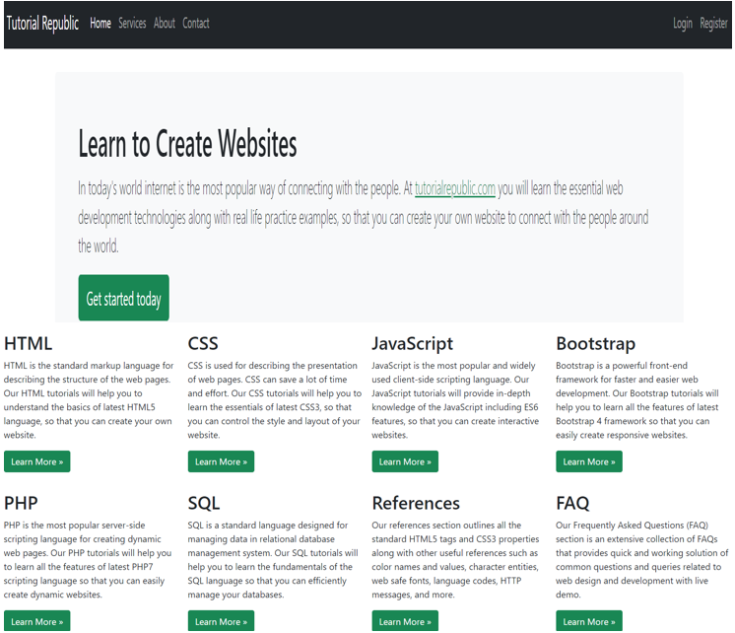

Program 2:
<!doctype html>
<html lang="en">
<head>
<!-- Required meta tags -->
<meta charset="utf-8">
<meta name="viewport" content="width=device-width, initial-scale=1, shrink-to-fit=no">
<!-- Bootstrap CSS -->
<link rel="stylesheet"
href="https://cdn.jsdelivr.net/npm/bootstrap@4.6.1/dist/css/bootstrap.min.css"
integrity="sha384-zCbKRCUGaJDkqS1kPbPd7TveP5iyJE0EjAuZQTgFLD2ylzuqKfdKlfG/eSrtxUkn" crossorigin="anonymous">

<title>Bootstrap Responsive Webpage</title>
</head>

<body>
<nav class="navbar navbar-expand-lg navbar-dark bg-dark">
<a class="navbar-brand" href="#">Bootstrap Responsive Webpage</a>
<button class="navbar-toggler" type="button" data-toggle="collapse" data-target="#navbarSupportedContent"
aria-controls="navbarSupportedContent" aria-expanded="false"
aria-label="Toggle navigation">
<span class="navbar-toggler-icon"></span>
</button>

<div class="collapse navbar-collapse" id="navbarSupportedContent">
<ul class="navbar-nav mr-auto">
<li class="nav-item active">
<a class="nav-link" href="#">Home <span class="sr-only">(current)</span></a>
</li>
<li class="nav-item">
<a class="nav-link" href="#">Link</a>
</li>
<li class="nav-item dropdown">
<a class="nav-link dropdown-toggle" href="#" id="navbarDropdown" role="button"
data-toggle="dropdown" aria-expanded="false">
Dropdown
</a>
<div class="dropdown-menu" aria-labelledby="navbarDropdown">
<a class="dropdown-item" href="#">Action</a>
<a class="dropdown-item" href="#">Another action</a>
<div class="dropdown-divider"></div>
<a class="dropdown-item" href="#">Something else here</a>
</div>
</li>
<li class="nav-item">
<a class="nav-link disabled">Disabled</a>
</li>
</ul>
<form class="form-inline my-2 my-lg-0">
<input class="form-control mr-sm-2" type="search" placeholder="Search"
aria-label="Search">
<button class="btn btn-outline-warning my-2 my-sm-0"
type="submit">Search</button>
</form>
</div>
</nav>

<div id="carouselExampleIndicators" class="carousel slide" data-ride="carousel">
<ol class="carousel-indicators">
<li data-target="#carouselExampleIndicators" data-slide-to="0" class="active"></li>
<li data-target="#carouselExampleIndicators" data-slide-to="1"></li>
<li data-target="#carouselExampleIndicators" data-slide-to="2"></li>
</ol>
<div class="carousel-inner">
<div class="carousel-item active">
<img src="https://source.unsplash.com/1600x500/?nature,water" class="d-block w-100" alt="...">
</div>
<div class="carousel-item">
<img src="https://source.unsplash.com/1600x500/?nature" class="d-block w-100" alt="...">
</div>
<div class="carousel-item">
<img src="https://source.unsplash.com/1600x500/?water" class="d-block w-100" alt="...">
</div>
</div>
<button class="carousel-control-prev" type="button" data-target="#carouselExampleIndicators" data-slide="prev">
<span class="carousel-control-prev-icon" aria-hidden="true"></span>
<span class="sr-only">Previous</span>
</button>
<button class="carousel-control-next" type="button"
data-target="#carouselExampleIndicators" data-slide="next">
<span class="carousel-control-next-icon" aria-hidden="true"></span>
<span class="sr-only">Next</span>
</button>
</div>

<div class="row mt-4 mb-2">
<div class="col-sm-6">
<div class="card bg-dark text-white">
<img src="https://source.unsplash.com/60x20/?plant" class="card-img" alt="...">
<div class="card-img-overlay">
<h5 class="card-title text-dark font-weight-bold">Card title</h5>
<p class="card-text text-dark font-weight-bold">This is a wider card with supporting text below as a natural lead-in to
additional content. This content is a little bit longer.</p>
<p class="card-text text-dark font-weight-bold">Last updated 3 mins ago</p>
</div>
</div>
</div>
<div class="col-sm-6">
<div class="card bg-dark text-white">
<img src="https://source.unsplash.com/60x20/?computer" class="card-img" alt="...">
<div class="card-img-overlay">
<h5 class="card-title text-dark font-weight-bold">Card title</h5>
<p class="card-text text-dark font-weight-bold">This is a wider card with supporting text below as a natural lead-in to
additional content. This content is a little bit longer.</p>
<p class="card-text text-dark font-weight-bold">Last updated 3 mins ago</p>
</div>
</div>
</div>
</div>

<div class="row mt-1 mb-4">
<div class="col-sm-6">
<div class="card bg-dark text-white">
<img src="https://source.unsplash.com/60x20/?bug" class="card-img" alt="...">
<div class="card-img-overlay">
<h5 class="card-title text-dark font-weight-bold">Card title</h5>
<p class="card-text text-dark font-weight-bold">This is a wider card with supporting text below as a natural lead-in to
additional content. This content is a little bit longer.</p>
<p class="card-text text-dark font-weight-bold">Last updated 3 mins ago</p>
</div>
</div>
</div>
<div class="col-sm-6">
<div class="card bg-dark text-white">
<img src="https://source.unsplash.com/60x20/?office" class="card-img" alt="...">
<div class="card-img-overlay">
<h5 class="card-title text-dark font-weight-bold">Card title</h5>
<p class="card-text text-dark font-weight-bold">This is a wider card with supporting text below as a natural lead-in to
additional content. This content is a little bit longer.</p>
<p class="card-text text-dark font-weight-bold">Last updated 3 mins ago</p>
</div>
</div>
</div>
</div>

<div class="card bg-light mx-2 mb-3">
<div class="card-header bg-light">
Featured
</div>
<div class="card-body">
<h5 class="card-title">Special title treatment</h5>
<p class="card-text">With supporting text below as a natural lead-in to additional content.</p>
<a href="#" class="btn btn-warning">Go somewhere</a>
</div>
</div>

<div class="row container">
<div class="col-sm-6">
<div class="card">
<div class="card-body">
<h5 class="card-title">Special title treatment</h5>
<p class="card-text">With supporting text below as a natural lead-in to additional content.</p>
<a href="#" class="btn btn-warning">Go somewhere</a>
</div>
</div>
</div>
<div class="col-sm-6">
<div class="card">
<div class="card-body">
<h5 class="card-title">Special title treatment</h5>
<p class="card-text">With supporting text below as a natural lead-in to additional content.</p>
<a href="#" class="btn btn-warning">Go somewhere</a>
</div>
</div>
</div>
</div>

<div class="container bg-light mx-3 pb-2 mt-4 pt-2">
<h3>Contact Us</h3>
<form>
<div class="form-group row">
<label for="inputEmail3" class="col-sm-2 col-form-label">Name</label>
<div class="col-sm-10">
<input type="text" class="form-control" id="inputEmail3">
</div>
</div>

<div class="form-group row">
<label for="inputEmail3" class="col-sm-2 col-form-label">Email</label>
<div class="col-sm-10">
<input type="email" class="form-control" id="inputEmail3">
</div>
</div>

<label for="validationTextarea">Message</label>
<textarea class="form-control" id="validationTextarea" placeholder="Share your concern here"></textarea>

<div class="form-group row mt-2">
<div class="col-sm-10">
<button type="submit" class="btn btn-warning">Submit</button>
</div>
</div>
</form>
</div>

<footer class="pt-4 my-md-5 pt-md-5 border-top container">
<div class="row">
<div class="col-12 col-md">
<img class="mb-2" src="https://getbootstrap.com/docs/4.6/assets/brand/bootstrap-solid.svg" alt="" width="24" height="24">
<small class="d-block mb-3 text-muted">© 2017-2022</small>
</div>
<div class="col-6 col-md">
<h5>Features</h5>
<ul class="list-unstyled text-small">
<li><a class="text-muted" href="#">Cool stuff</a></li>
<li><a class="text-muted" href="#">Random feature</a></li>
<li><a class="text-muted" href="#">Team feature</a></li>
<li><a class="text-muted" href="#">Stuff for developers</a></li>
<li><a class="text-muted" href="#">Another one</a></li>
<li><a class="text-muted" href="#">Last time</a></li>
</ul>
</div>
<div class="col-6 col-md">
<h5>Resources</h5>
<ul class="list-unstyled text-small">
<li><a class="text-muted" href="#">Resource</a></li>
<li><a class="text-muted" href="#">Resource name</a></li>
<li><a class="text-muted" href="#">Another resource</a></li>
<li><a class="text-muted" href="#">Final resource</a></li>
</ul>
</div>
<div class="col-6 col-md">
<h5>About</h5>
<ul class="list-unstyled text-small">
<li><a class="text-muted" href="#">Team</a></li>
<li><a class="text-muted" href="#">Locations</a></li>
<li><a class="text-muted" href="#">Privacy</a></li>
<li><a class="text-muted" href="#">Terms</a></li>
</ul>
</div>
</div>
</footer>

<script src="https://cdn.jsdelivr.net/npm/jquery@3.5.1/dist/jquery.slim.min.js"
integrity="sha384-DfXdz2htPH0lsSSs5nCTpuj/zy4C+OGpamoFVy38MVBnE+IbbVYUew+OrCXaRkfj"
crossorigin="anonymous"></script>
<script src="https://cdn.jsdelivr.net/npm/bootstrap@4.6.1/dist/js/bootstrap.bundle.min.js"
integrity="sha384-fQybjgWLrvvRgtW6bFlB7jaZrFsaBXjsOMm/tB9LTS58ONXgqbR9W8oWht/amnpF"
crossorigin="anonymous"></script>

</body>

</html>

Output/Results snippet:
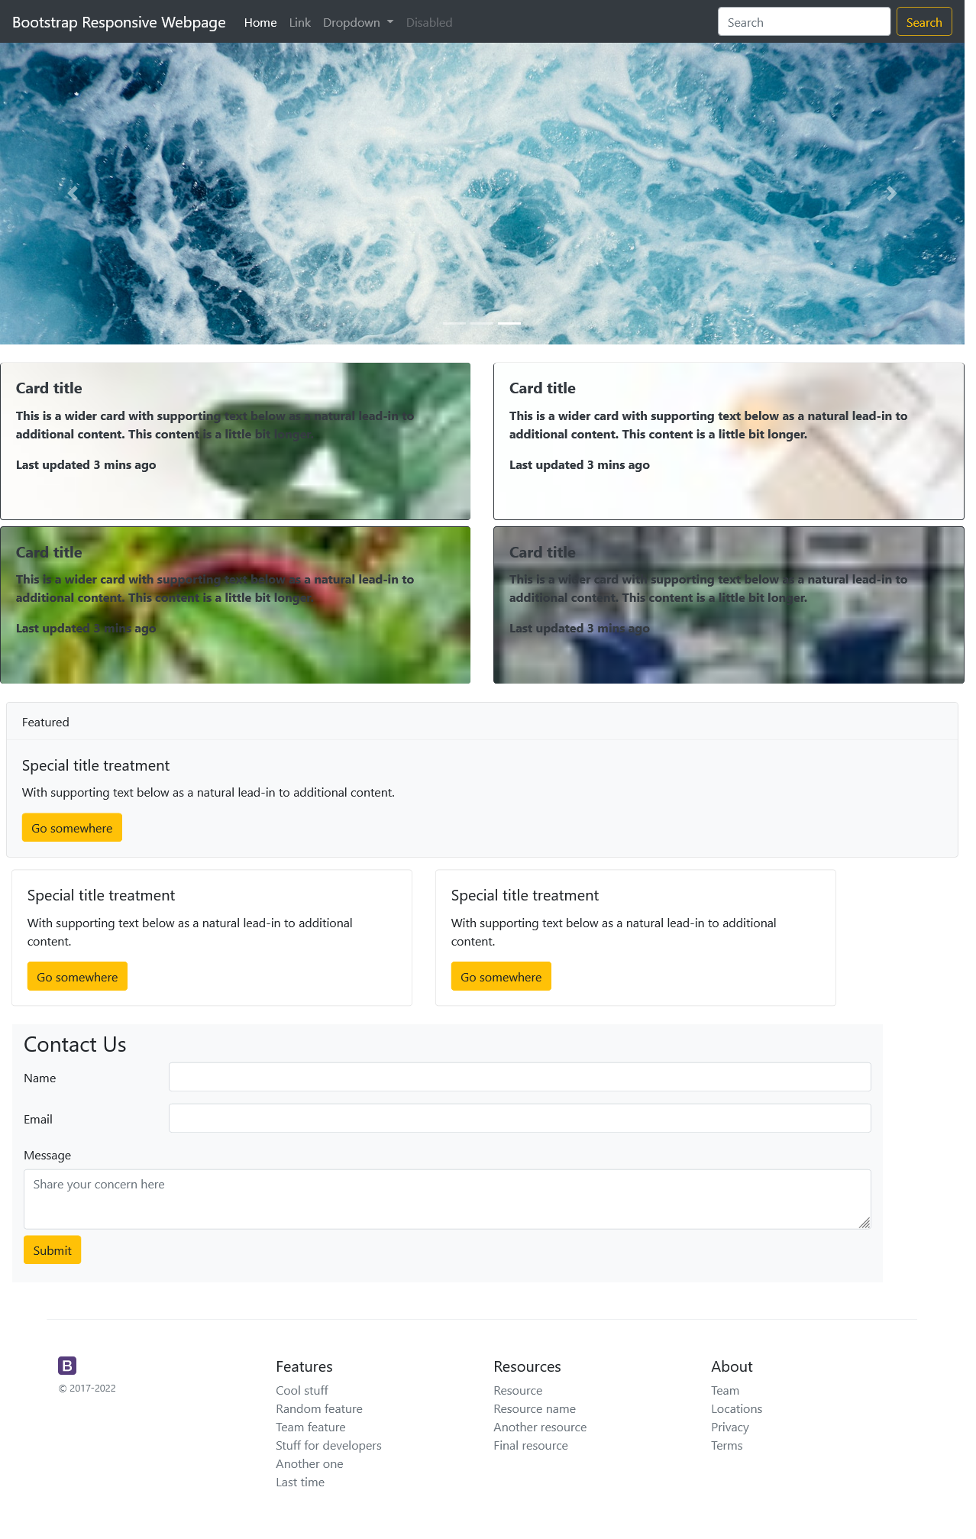
References:
- https://www.geeksforgeeks.org/create-a-single-page-responsive-website-using-bootstrap/
- https://getbootstrap.com/ (v4.6)
- https://unsplash.com/

Activity 2
Aim: Use jQuery selectors to identify elements with some properties in a hypothetical page
Learning outcome: Able to identify elements with following properties in a hypothetical page:
- All p tags that have no children, but only if they don't have a class of ignore
- Any element with the text ""REPLACE_ME"" in it.
- All div tags with a child that has a class of special will fade out
- All heading elements (h1, h2, h3, h4, h5, h6)
- Every other visible li
Duration: 2 hours
List of Hardware/Software requirements:
1. Laptop/Computer with Windows OS
2. Bootstrap v4.6 and a Browser
Program 1: All p tags that have no children, but only if they don't have a class of ignore
<!doctype html>
<html lang="en">
<head>
<!-- Required meta tags -->
<meta charset="utf-8">
<meta name="viewport" content="width=device-width, initial-scale=1, shrink-to-fit=no">
<!-- Bootstrap CSS -->
<link rel="stylesheet"
href="https://cdn.jsdelivr.net/npm/bootstrap@4.6.1/dist/css/bootstrap.min.css"
integrity="sha384-zCbKRCUGaJDkqS1kPbPd7TveP5iyJE0EjAuZQTgFLD2ylzuqKfdKlfG/eSrtxUkn" crossorigin="anonymous">
<title>App P tags</title>
</head>
<body>
<div class="container">
<h3>Task -1<br>All p tags that have no children, but only if they don't have a class of ignore will hide when
click on bellow button
</h3>
<button type="button" name="click" id="click">Click me</button>
</div>
<div class="container">
<p>
<h4>1.p tag having one child</h4>
</p>
<p>2. p tag don't have any child</p>
<p>
<h4 class="ignore">3.p tag have child with class ignore</h4>
</p>
<p>4.p tag don't have any child</p>
<p class="ignore">5.p tag don't have any child but have class ignore</p>
</div>
<script src="https://cdn.jsdelivr.net/npm/jquery@3.5.1/dist/jquery.slim.min.js"
integrity="sha384-DfXdz2htPH0lsSSs5nCTpuj/zy4C+OGpamoFVy38MVBnE+IbbVYUew+OrCXaRkfj"
crossorigin="anonymous"></script>
<script>
$(document).ready(function(){
$('#click').click(function(){
$('p:not(.ignore)').hide();
});
});
</script>
</body>
</html>
Output/Results snippet:
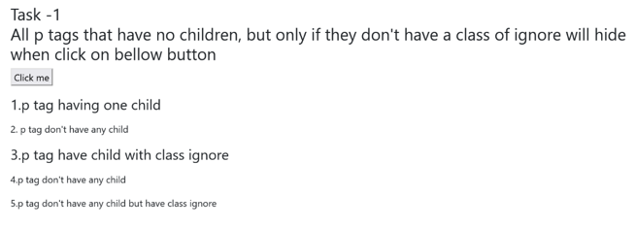
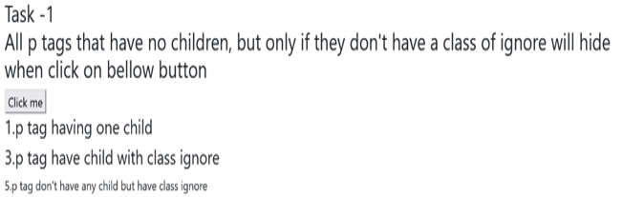

Program 2: Any element with the text ""REPLACE_ME"" in it.
<!doctype html>
<html lang="en">
<head>
<!-- Required meta tags -->
<meta charset="utf-8">
<meta name="viewport" content="width=device-width, initial-scale=1, shrink-to-fit=no">
<!-- Bootstrap CSS -->
<link rel="stylesheet"
href="https://cdn.jsdelivr.net/npm/bootstrap@4.6.1/dist/css/bootstrap.min.css"
integrity="sha384zCbKRCUGaJDkqS1kPbPd7TveP5iyJE0EjAuZQTgFLD2ylzuqKfdKlfG/eSrtxUkn" crossorigin="anonymous">
<title>Replace me</title>
</head>
<body>
<div class="container">
<h3>Task-2<br>Any element with the text "REPLACE_ME" in it, it will replace with "REPLACED!" on click of bellow
button</h3>
<button type="button" name="click" id="click">Click me</button>
<div>
<p> REPLACE_ME </p>
<p> Hi </p>
<p> REPLACE_ME </p>
<p> Lorem ipsum dolor sit amet. </p>
<p> Whatsapp...! </p>
</div>
</div>
<script src="https://cdn.jsdelivr.net/npm/jquery@3.5.1/dist/jquery.slim.min.js"
integrity="sha384DfXdz2htPH0lsSSs5nCTpuj/zy4C+OGpamoFVy38MVBnE+IbbVYUew+OrCXaRkfj"
crossorigin="anonymous"></script>
<script>
$(document).ready(function () {
$('#click').click(function () {
$('p:contains(REPLACE_ME)').replaceWith("REPLACED!");
});
});
</script>
</body>
</html>
Output/Results snippet:
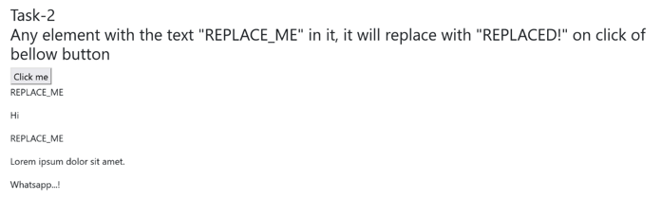
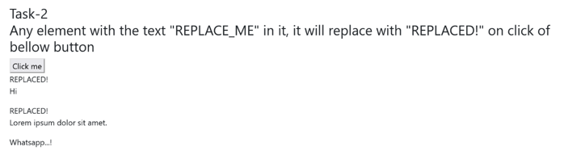
Program 3: All div tags with a child that has a class of special will fade out
<!doctype html>
<html lang="en">
<head>
<!-- Required meta tags -->
<meta charset="utf-8">
<meta name="viewport" content="width=device-width, initial-scale=1, shrink-to-fit=no">
<!-- Bootstrap CSS -->
<link rel="stylesheet"
href="https://cdn.jsdelivr.net/npm/bootstrap@4.6.1/dist/css/bootstrap.min.css"
integrity="sha384zCbKRCUGaJDkqS1kPbPd7TveP5iyJE0EjAuZQTgFLD2ylzuqKfdKlfG/eSrtxUkn" crossorigin="anonymous">
<title>All div tags with a child that has a class of special will shift left on click of bellow button</title>
<script src="https://ajax.googleapis.com/ajax/libs/jquery/3.5.1/jquery.min.js"></script>
<script>
$(document).ready(function () {
$('#click').click(function () {
$("div.block:has(p.special)").fadeOut("slow");
});
});
</script>
</head>
<body>
<div class="container">
<h3>Task-2<br>All div tags with a child that has a class of special class will fade out.
</h3>
<button type="button" name="click" id="click">Click here</button>
<div class="block">
<p class="special">I am Special Class in p tag
</div>
</div>
</body>
</html>
Output/Results snippet:
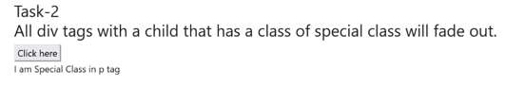
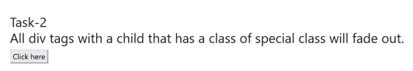
Program 4: All heading elements (h1, h2, h3, h4, h5, h6)
<!doctype html>
<html lang="en">
<head>
<!-- Required meta tags -->
<meta charset="utf-8">
<meta name="viewport" content="width=device-width, initial-scale=1, shrink-to-fit=no">
<!-- Bootstrap CSS -->
<link rel="stylesheet"
href="https://cdn.jsdelivr.net/npm/bootstrap@4.6.1/dist/css/bootstrap.min.css"
integrity="sha384zCbKRCUGaJDkqS1kPbPd7TveP5iyJE0EjAuZQTgFLD2ylzuqKfdKlfG/eSrtxUkn" crossorigin="anonymous">
<title>All Heading elements</title>
</head>
<body>
<div class="container">
<h3>Task-4<br>All heading elements (h1,h2,h3,h4,h5,h6) change on click of bellow button</h3>
<button type="button" name="click" id="click">Click me</button>
<div>
<p>its paragraph tag</p>
<h1>its h1 tag</h1>
<h2>its h2 tag</h2>
<p>its paragraph tag</p>
<h3>its h3 tag</h3>
<h4>its h4 tag</h4>
<h5>its h5 tag</h5>
<p>its paragraph tag</p>
<h6>its h6 tag</h6>
</div>
</div>
<script src="https://cdn.jsdelivr.net/npm/jquery@3.5.1/dist/jquery.slim.min.js"
integrity="sha384DfXdz2htPH0lsSSs5nCTpuj/zy4C+OGpamoFVy38MVBnE+IbbVYUew+OrCXaRkfj"
crossorigin="anonymous"></script>
<script>
$(document).ready(function () {
$('#click').click(function(){
$(':header').css({"color":"red"});
});
});
</script>
</body>
</html>

Output/Results snippet:
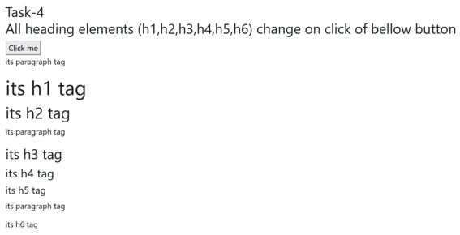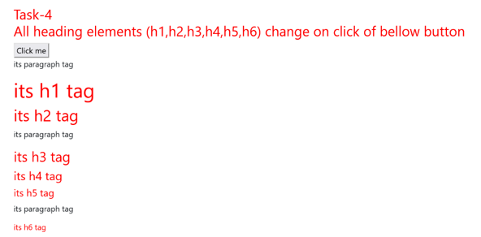
References:
- https://www.w3schools.com/jquery/tryit.asp?filename=tryjquery_eff_show_hide
- https://www.w3schools.com/jquery/html_replacewith.asp
- https://api.jquery.com/replacewith/
- https://www.w3schools.com/jquery/tryit.asp?filename=tryjquery_eff_fadeout_fadein
- https://sebhastian.com/jquery-change-background-color/

Activity 3
Aim: Write jQuery Code to change the hyperlink and the text of an existing link
Learning outcome: Able to change the hyperlink and the text of an existing link
Duration: 30 minutes
List of Hardware/Software requirements:
1. Laptop/Computer with Windows OS
2. Bootstrap v4.6 and a Browser
Program:
<!doctype html>
<html lang="en">
<head>
<!-- Required meta tags -->
<meta charset="utf-8">
<meta name="viewport" content="width=device-width, initial-scale=1, shrink-to-fit=no">
<!-- Bootstrap CSS -->
<link rel="stylesheet"
href="https://cdn.jsdelivr.net/npm/bootstrap@4.6.1/dist/css/bootstrap.min.css"
integrity="sha384zCbKRCUGaJDkqS1kPbPd7TveP5iyJE0EjAuZQTgFLD2ylzuqKfdKlfG/eSrtxUkn" crossorigin="anonymous">
<title>change the hyperlink and the text</title>
</head>
<body>
<div class="container">
<h3>Write a jQuery Code to change the hyperlink and the text of a existing link</h3>
<a href="https://www.w3schools.com/jquery/default.asp" >w3schools - Jquery</a>
</div>
<script src="https://cdn.jsdelivr.net/npm/jquery@3.5.1/dist/jquery.slim.min.js"
integrity="sha384DfXdz2htPH0lsSSs5nCTpuj/zy4C+OGpamoFVy38MVBnE+IbbVYUew+OrCXaRkfj"
crossorigin="anonymous"></script>
<script>
$("a").attr("href", "https://www.w3schools.com/js/default.asp");
$("a").text("w3schools - Javascript");
</script>
</body>
</html>
Output/Results snippet:
References:
- https://www.w3resource.com/jquery-exercises/jquery-core-exercise-9.php

Activity 4
Aim: How to Print a Page Using JQuery
Learning outcome: To Print a Page Using JQuery
Duration: 30 minutes
List of Hardware/Software requirements:
1. Laptop/Computer with Windows OS
2. Bootstrap v4.6 and a Browser
Program:
<!doctype html>
<html lang="en">
<head>
<!-- Required meta tags -->
<meta charset="utf-8">
<meta name="viewport" content="width=device-width, initial-scale=1, shrink-to-fit=no">
<!-- Bootstrap CSS -->
<link rel="stylesheet"
href="https://cdn.jsdelivr.net/npm/bootstrap@4.6.1/dist/css/bootstrap.min.css"
integrity="sha384zCbKRCUGaJDkqS1kPbPd7TveP5iyJE0EjAuZQTgFLD2ylzuqKfdKlfG/eSrtxUkn" crossorigin="anonymous">
<title>Print this page</title>
</head>
<body>
<div class="container">
<h3>Print a Page Using JQuery</h3>
<div>
<p>Lorem, ipsum dolor sit amet consectetur adipisicing elit. Tempora corrupti animi voluptas sunt beatae eum harum veniam in labore tenetur, quos at, velit consectetur quas!</p>
<a class="printPage" href="#">Print</a>
</div>
</div>
<script src="https://cdn.jsdelivr.net/npm/jquery@3.5.1/dist/jquery.slim.min.js"
integrity="sha384DfXdz2htPH0lsSSs5nCTpuj/zy4C+OGpamoFVy38MVBnE+IbbVYUew+OrCXaRkfj"
crossorigin="anonymous"></script>
<script>
$('a.printPage').click(function(){
window.print();
return false;
});
</script>
</body>
</html>

Output/Results snippet:
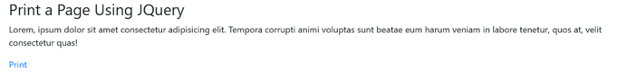
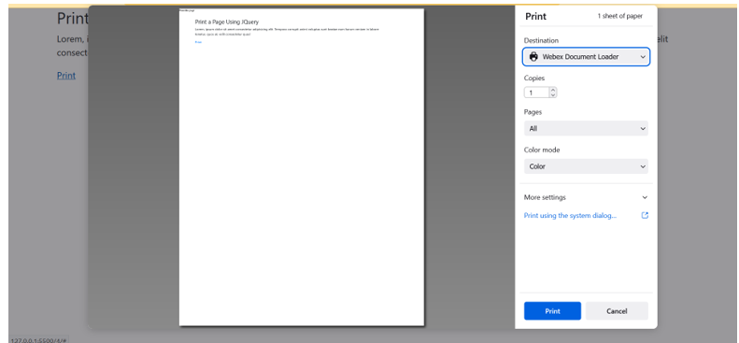
References:
- https://www.geeksforgeeks.org/how-to-print-a-page-using-jquery/

Activity 5
Aim: Display and hide message shown in the div tag on click of the buttons
Learning outcome: Able to display and hide message shown in the div tag on click of the buttons
Duration: 30 minutes
List of Hardware/Software requirements:
1. Laptop/Computer with Windows OS
2. Bootstrap v4.6 and a Browser
Program:
<!doctype html>
<html lang="en">
<head>
<!-- Required meta tags -->
<meta charset="utf-8">
<meta name="viewport" content="width=device-width, initial-scale=1, shrink-to-fit=no">
<!-- Bootstrap CSS -->
<link rel="stylesheet"
href="https://cdn.jsdelivr.net/npm/bootstrap@4.6.1/dist/css/bootstrap.min.css"
integrity="sha384zCbKRCUGaJDkqS1kPbPd7TveP5iyJE0EjAuZQTgFLD2ylzuqKfdKlfG/eSrtxUkn" crossorigin="anonymous">
<title>Display and hide message</title>
</head>
<body>
<span class="container">
<h3>Display and hide message shown in the div tag on click of the buttons.</h3>
</span>
<div>Lorem, ipsum dolor sit amet consectetur adipisicing elit. Tempora corrupti animi voluptas sunt beatae eum harum
veniam in labore tenetur, quos at, velit consectetur quas!</div>
<button id="hide">Hide</button>
<button id="show">Show</button>
<script src="https://cdn.jsdelivr.net/npm/jquery@3.5.1/dist/jquery.slim.min.js"
integrity="sha384DfXdz2htPH0lsSSs5nCTpuj/zy4C+OGpamoFVy38MVBnE+IbbVYUew+OrCXaRkfj"
crossorigin="anonymous"></script>
<script>
$(document).ready(function () {
$("#hide").click(function () {
$("div").hide();
});
$("#show").click(function () {
$("div").show();
});
});
</script>
</body>
</html>
Output/Results snippet:
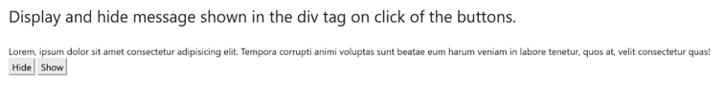
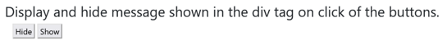
References:
- https://www.w3schools.com/howto/howto_js_toggle_hide_show.asp

Activity 6
Aim: Create one button and a textbox. On click of the button the text written in text box should display on the button
Learning outcome: Able to create one button and a textbox. On click of the button the text written in text box should display on the button
Duration: 1 hour
List of Hardware/Software requirements:
1. Laptop/Computer with Windows OS
2. Bootstrap v4.6 and a Browser
Program:
<!doctype html>
<html lang="en">
<head>
<!-- Required meta tags -->
<meta charset="utf-8">
<meta name="viewport" content="width=device-width, initial-scale=1, shrink-to-fit=no">
<!-- Bootstrap CSS -->
<link rel="stylesheet"
href="https://cdn.jsdelivr.net/npm/bootstrap@4.6.1/dist/css/bootstrap.min.css"
integrity="sha384zCbKRCUGaJDkqS1kPbPd7TveP5iyJE0EjAuZQTgFLD2ylzuqKfdKlfG/eSrtxUkn" crossorigin="anonymous">
<title>Create a button and a textbox. On click of the button the text written in text box should display on the button</title>
<script type="text/javascript"
src="http://ajax.googleapis.com/ajax/libs/jquery/1.8.3/jquery.min.js"></script>
<script type="text/javascript">
$(function () {
$("input[name=btnPassport]").click(function () {
if ($(this).val() == "Yes") {
$("#dvPassport").show();
} else {
$("#dvPassport").hide();
}
});
});
</script>
</head>
<body>
<div class="container">
<h3>Create a button and a textbox. On click of the button the text written in text box should display on the button</h3>
<span>Do you have Passport?</span>
<input type="button" value="Yes" name="btnPassport" />
<input type="button" value="No" name="btnPassport" />
<hr />
<div id="dvPassport" style="display: none">
Passport Number:
<input type="text" id="txtPassportNumber" />
</div>
</div>
</body>
</html>
Output/Results snippet:
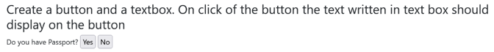
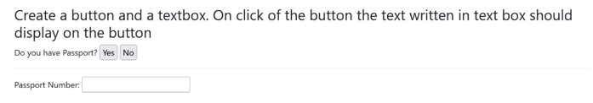
References:
- https://www.aspsnippets.com/Articles/Show-Hide-TextBox-on-Button-Click-using-JavaScript-and-jQuery.aspx

Activity 7
Aim: Toggle a specified class when an element is clicked
Learning outcome: Able to toggle a specified class when an element is clicked
Duration: 30 minutes
List of Hardware/Software requirements:
1. Laptop/Computer with Windows OS
2. Bootstrap v4.6 and a Browser
Program:
<!doctype html>
<html lang="en">
<head>
<!-- Required meta tags -->
<meta charset="utf-8">
<meta name="viewport" content="width=device-width, initial-scale=1, shrink-to-fit=no">
<!-- Bootstrap CSS -->
<link rel="stylesheet"
href="https://cdn.jsdelivr.net/npm/bootstrap@4.6.1/dist/css/bootstrap.min.css"
integrity="sha384zCbKRCUGaJDkqS1kPbPd7TveP5iyJE0EjAuZQTgFLD2ylzuqKfdKlfG/eSrtxUkn" crossorigin="anonymous">
<style>
p {
margin: 5px;
font-size: 15px;
cursor: pointer;
}
.highlight {
background:
#F4FA58;
}
</style>
<title>Toggle a specified class</title>
</head>
<body>
<div class="container">
<h3>Toggle a specified class when an element is clicked.</h3>
<p>Click on the Paragraphs</p>
<p>jQuery Exercises</p>
<p>JavaScript Exercises</p>
</div>
<script src="https://cdn.jsdelivr.net/npm/jquery@3.5.1/dist/jquery.slim.min.js"
integrity="sha384DfXdz2htPH0lsSSs5nCTpuj/zy4C+OGpamoFVy38MVBnE+IbbVYUew+OrCXaRkfj"
crossorigin="anonymous"></script>
<script>
$("p").click(function () {
$(this).toggleClass("highlight");
});
</script>
</body>
</html>
Output/Results snippet:
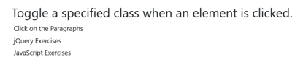
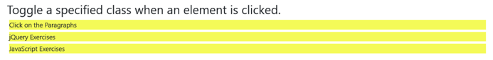
References:
- https://www.w3resource.com/jquery-exercises/jquery-css-exercise-10.php

Activity 8
Aim: Disable the submit button until the visitor has clicked a check box
Learning outcome: To disable the submit button until the visitor has clicked a check box
Duration: 30 minutes
List of Hardware/Software requirements:
1. Laptop/Computer with Windows OS
2. Bootstrap v4.6 and a Browser
Program:
<!doctype html>
<html lang="en">
<head>
<!-- Required meta tags -->
<meta charset="utf-8">
<meta name="viewport" content="width=device-width, initial-scale=1, shrink-to-fit=no">
<!-- Bootstrap CSS -->
<link rel="stylesheet"
href="https://cdn.jsdelivr.net/npm/bootstrap@4.6.1/dist/css/bootstrap.min.css"
integrity="sha384zCbKRCUGaJDkqS1kPbPd7TveP5iyJE0EjAuZQTgFLD2ylzuqKfdKlfG/eSrtxUkn" crossorigin="anonymous">
<title>Disable the submit button until the visitor has clicked a check box.</title>
</head>
<body>
<div class="container">
<h3>Disable the submit button until the visitor has clicked a check box.</h3>
<form>
<div class="mb-3">
<label for="exampleInputEmail1" class="form-label">Email address</label>
<input type="email" class="form-control" id="exampleInputEmail1"
aria-describedby="emailHelp">
</div>
<div class="mb-3 form-check">
<input id="accept" name="accept" type="checkbox" value="y"/>
<label class="form-check-label" for="exampleCheck1">I accept</label>
</div>
<input id="submitbtn" disabled="disabled" name="Submit" type="submit"
value="Submit" />
</form>
</div>
<script src="https://cdn.jsdelivr.net/npm/jquery@3.5.1/dist/jquery.slim.min.js"
integrity="sha384DfXdz2htPH0lsSSs5nCTpuj/zy4C+OGpamoFVy38MVBnE+IbbVYUew+OrCXaRkfj"
crossorigin="anonymous"></script>
<script>
$('#accept').click(function () {
if ($('#submitbtn').is(':disabled')) {
$('#submitbtn').removeAttr('disabled');
} else {
$('#submitbtn').attr('disabled', 'disabled');
}
});
</script>
</body>
</html>
Output/Results snippet:
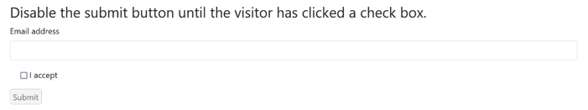
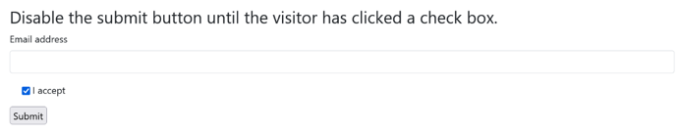
References:
- https://www.w3resource.com/jquery-exercises/part1/jquery-practical-exercise-4.php

Activity 9
Aim: Create a text input field. Listen for the key up event. Alert the value of the text box whenever key up occurs
Learning outcome: To create a text input field and listen for the key up event and also alert the value of the text box whenever key up occurs
Duration: 1 hour
List of Hardware/Software requirements:
1. Laptop/Computer with Windows OS
2. Bootstrap v4.6 and a Browser
Program:
<!doctype html>
<html lang="en">
<head>
<!-- Required meta tags -->
<meta charset="utf-8">
<meta name="viewport" content="width=device-width, initial-scale=1, shrink-to-fit=no">
<!-- Bootstrap CSS -->
<link rel="stylesheet"
href="https://cdn.jsdelivr.net/npm/bootstrap@4.6.1/dist/css/bootstrap.min.css"
integrity="sha384zCbKRCUGaJDkqS1kPbPd7TveP5iyJE0EjAuZQTgFLD2ylzuqKfdKlfG/eSrtxUkn" crossorigin="anonymous">
<title>Create a text input field. Listen for the keyup event. Alert the value of the text box whenever keyup occurs.
</title>
</head>
<body>
<div class="container">
<h3>Create a text input field. Listen for the keyup event. Alert the value of the text box whenever keyup
occurs. </h3>
<form>
<div class="mb-3">
<label for="exampleInputEmail1" class="form-label">Enter your name: </label>
<input type="text" class="form-control" id="exampleInputEmail1" aria-describedby="emailHelp">
</div>
</form>
</div>
<script src="https://cdn.jsdelivr.net/npm/jquery@3.5.1/dist/jquery.slim.min.js"
integrity="sha384DfXdz2htPH0lsSSs5nCTpuj/zy4C+OGpamoFVy38MVBnE+IbbVYUew+OrCXaRkfj"
crossorigin="anonymous"></script>
<script>
$(document).ready(function () {
$("input").keydown(function () {
$("input").css("background-color", "yellow");
});
$("input").keyup(function () {
$("input").css("background-color", "pink");
});
});
</script>
</body>
</html>
Output/Results snippet:
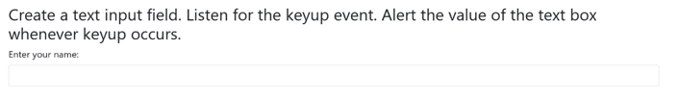
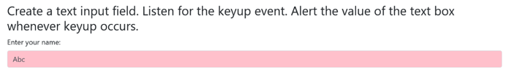
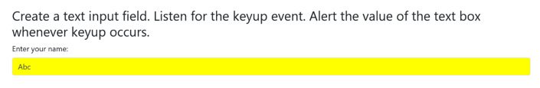
References:
- https://www.w3schools.com/jquery/tryit.asp?filename=tryjquery_event_keydown_keyup

Activity 10
Aim: Set a timer to delay execution of subsequent items in the queue
Learning outcome: To set a timer and delay execution of subsequent items in the queue
Duration: 30 minutes
List of Hardware/Software requirements:
1. Laptop/Computer with Windows OS
2. Bootstrap v4.6 and a Browser
Program:
<!doctype html>
<html lang="en">
<head>
<!-- Required meta tags -->
<meta charset="utf-8">
<meta name="viewport" content="width=device-width, initial-scale=1, shrink-to-fit=no">
<!-- Bootstrap CSS -->
<link rel="stylesheet"
href="https://cdn.jsdelivr.net/npm/bootstrap@4.6.1/dist/css/bootstrap.min.css"
integrity="sha384zCbKRCUGaJDkqS1kPbPd7TveP5iyJE0EjAuZQTgFLD2ylzuqKfdKlfG/eSrtxUkn" crossorigin="anonymous">
<title>Set a timer to delay execution of subsequent items in the queue.
</title>
<script src="https://ajax.googleapis.com/ajax/libs/jquery/3.5.1/jquery.min.js"></script>
<script>
$(document).ready(function () {
$("button").click(function () {
$("#div1").delay("slow").fadeIn();
$("#div2").delay("fast").fadeIn();
$("#div3").delay(800).fadeIn();
$("#div4").delay(2000).fadeIn();
$("#div5").delay(4000).fadeIn();
});
});
</script>
</head>
<body>
<div class="container">
<h3>Set a timer to delay execution of subsequent items in the queue. </h3>
<p>delay() method sets different speed values.</p>
<button>Click to fade in boxes with a delay</button></p>
<div id="div1" style="width:90px;height:90px;display:none;background-
color:black;"></div><br>
<div id="div2" style="width:90px;height:90px;display:none;background-
color:green;"></div><br>
<div id="div3" style="width:90px;height:90px;display:none;background-
color:blue;"></div><br>
<div id="div4" style="width:90px;height:90px;display:none;background-
color:red;"></div><br>
<div id="div5" style="width:90px;height:90px;display:none;background-
color:purple;"></div><br>
</div>
</body>
</html>
Output/Results snippet:
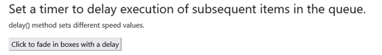
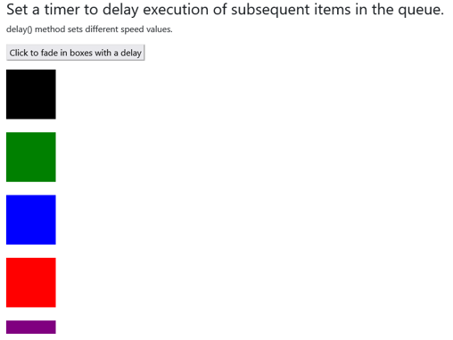
References:
- https://www.w3schools.com/jquery/eff_delay.asp

Activity 11
Aim: Find all the text nodes inside a paragraph and wrap them with an italic tag
Learning outcome: Able to find all the text nodes inside a paragraph and wrap them with an italic tag
Duration: 1 hour
List of Hardware/Software requirements:
1. Laptop/Computer with Windows OS
2. Bootstrap v4.6 and a Browser
Program:
<!doctype html>
<html lang="en">
<head>
<!-- Required meta tags -->
<meta charset="utf-8">
<meta name="viewport" content="width=device-width, initial-scale=1, shrink-to-fit=no">
<!-- Bootstrap CSS -->
<link rel="stylesheet"
href="https://cdn.jsdelivr.net/npm/bootstrap@4.6.1/dist/css/bootstrap.min.css"
integrity="sha384zCbKRCUGaJDkqS1kPbPd7TveP5iyJE0EjAuZQTgFLD2ylzuqKfdKlfG/eSrtxUkn" crossorigin="anonymous">
<title>Find all the text nodes inside a paragraph and wrap them with an italic tag.</title>
</head>
<body>
<div class="container">
<h3>Find all the text nodes inside a paragraph and wrap them with an italic tag. </h3>
<p><a href="https://www.w3resource.com/jquery-exercises/">jQuery</a> Exercises,
Practice and Solution</p>
<p><a href="https://www.w3resource.com/javascript-exercises/">JavaScript</a> Exercises,
Practice and Solution
</p>
</div>
<script src="https://ajax.googleapis.com/ajax/libs/jquery/3.5.1/jquery.min.js"></script>
<script>
$("p")
.contents()
.filter(function () {
return this.nodeType !== 1;
})
.wrap("<i></i>");
</script>
</body>
</html>

Output/Results snippet:
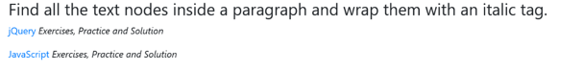
References:
- https://www.w3resource.com/jquery-exercises/2/jquery-fundamental-exercise-60.php

Activity 12
Aim: Write a jquery to attach a change event to the select element (Use to create a drop-down list.) that gets the text for each selected option and writes them in a paragraph
Learning outcome: To attach a change event to the select element (Use to create a drop-down list.) that gets the text for each selected option and writes them in a paragraph
Duration: 1 hour
List of Hardware/Software requirements:
1. Laptop/Computer with Windows OS
2. Bootstrap v4.6 and a Browser
Program:
<!doctype html>
<html lang="en">
<head>
<!-- Required meta tags -->
<meta charset="utf-8">
<meta name="viewport" content="width=device-width, initial-scale=1, shrink-to-fit=no">
<!-- Bootstrap CSS -->
<link rel="stylesheet"
href="https://cdn.jsdelivr.net/npm/bootstrap@4.6.1/dist/css/bootstrap.min.css" integrity="sha384zCbKRCUGaJDkqS1kPbPd7TveP5iyJE0EjAuZQTgFLD2ylzuqKfdKlfG/eSrtxUkn" crossorigin="anonymous">
<title>Write a jquery to attach a change event to the select element (Use to create a drop-down list.) that gets the
text for each selected option and writes them in a paragraph.</title>
</head>
<body>
<div class="container">
<h3>Write a jquery to attach a change event to the select element (Use to create a drop-down list.) that gets the text for each selected option and writes them in a paragraph.</h3>
<select name="colors" multiple="multiple">
<option>Red</option>
<option>Green</option>
<option>Blue</option>
<option>Orange</option>
<option>Black</option>
<option>White</option>
</select>
<p></p>
</div>
<script src="https://ajax.googleapis.com/ajax/libs/jquery/3.5.1/jquery.min.js"></script>
<script>
var foo = function (value) {
console.log("foo: " + value);
};
var callbacks = $.Callbacks();
$("select")
.change(function () {
var str = "";
$("select option:selected").each(function () {
str += $(this).text() + " ";
});
$("p").text("Selected Colors: " + str).css("color", "blue");
})
.change();
</script>
</body>
</html>
Output/Results snippet:
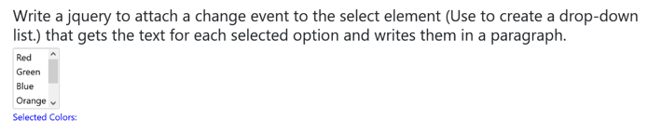
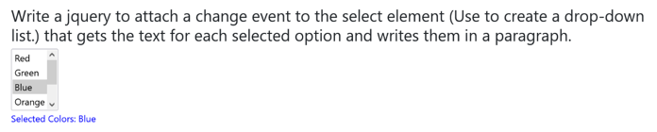
References:
- https://www.w3resource.com/jquery-exercises/2/jquery-fundamental-exercise-53.php

Activity 13
Aim: Find the widths and heights of various elements. Get the scroll top and left of an element. Access the position of an element.
Learning outcome: Able to find the widths and heights of various elements. Get the scroll top and left of an element. Access the position of an element.
Duration: 1 hour
List of Hardware/Software requirements:
1. Laptop/Computer with Windows OS
2. Bootstrap v4.6 and a Browser
Program:
<!doctype html>
<html lang="en">
<head>
<!-- Required meta tags -->
<meta charset="utf-8">
<meta name="viewport" content="width=device-width, initial-scale=1, shrink-to-fit=no">
<!-- Bootstrap CSS -->
<link rel="stylesheet"
href="https://cdn.jsdelivr.net/npm/bootstrap@4.6.1/dist/css/bootstrap.min.css" integrity="sha384zCbKRCUGaJDkqS1kPbPd7TveP5iyJE0EjAuZQTgFLD2ylzuqKfdKlfG/eSrtxUkn" crossorigin="anonymous">
<title>Find the widths and heights of various elements. Get the scroll top and left of an element. Access the position of an element.</title>
<style>
p {
margin-top: 20px;
margin-left: 10px;
padding: 5px;
border: 2px solid #666;
}
</style>
</head>
<body>
<div class="container">
<h3>Find the widths and heights of various elements. Get the scroll top and left of an element. Access the position of an element.</h3>
<div
style="height:75px;width:200px;padding:10px;margin:3px;border:1px solid rgba(15, 95, 25, 0.678);background-color:#035770;">
</div>
</div>
<p> </p>
<p>This is a paragraph.</p>
<button>Return the top and left position of the p element</button>
<script src="https://ajax.googleapis.com/ajax/libs/jquery/3.5.1/jquery.min.js"></script>
<script>
console.log("The width of the h3 tag is:" + $("h3").width());
console.log("The width of the div is:" + $("div").width());
console.log("Scroll left, top position of the Paragraph are:" + $("p").scrollLeft() + ',' + $("p").scrollTop());
</script>
<script>
$(document).ready(function () {
$("button").click(function () {
var x = $("p").position();
alert("Top position: " + x.top + " Left position: " + x.left);
});
});
</script>
</body>
</html>
Output/Results snippet:
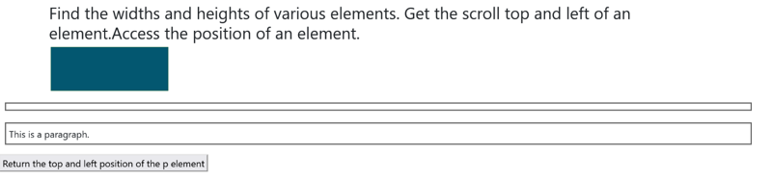
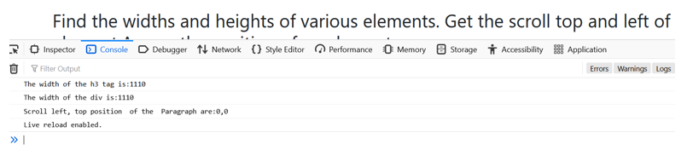

References:
- https://www.w3resource.com/jquery-exercises/jquery-css-exercise-4.php
- https://www.w3schools.com/jquery/tryit.asp?filename=tryjquery_css_position
- https://www.w3resource.com/jquery-exercises/jquery-css-exercise-3.php

